Index
First. 2
What is uCP? 2
Demo scene setup instruction. 3
Demo scene “Demo-Index” 3
Demo scene “Demo-HowTo” 4
Demo scene “Demo-PresetSample” 4
Demo scene “Demo-Animation” 4
Demo scene “Demo-WorldUI” 4
Demo scene “Demo-D&M” 5
How to use prefabs 6
How to create a color picker without prefab 7
Step 1. Create a Base 7
Step 2. Create controls 7
Step 3. Put Components 7
Step 4. Create a Hue control 8
Step 5. Color Pointer 11
Smaller structure 12
Useful scripts. 13
About ColorPicker.cs. 14
World UI 15
About Filled Type Image 16
Contact 17

First.
Thank you for downlolading uGUI Color Picker – uCP.

What is uCP?
uCP is a color picker that works on new Unity GUI system.
It works on all rendermode of canvas, overray, screen and world.
So you can put a color picker any where.
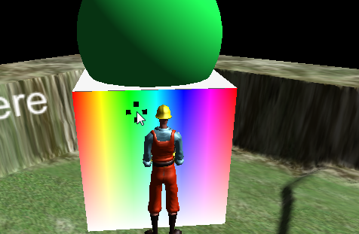
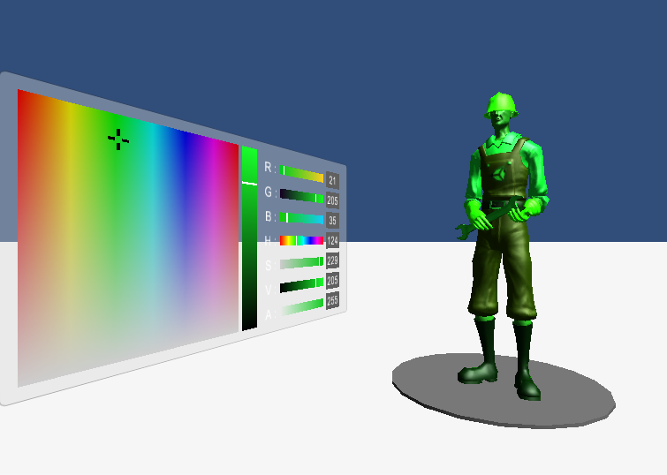

Demo scene setup instruction.
When you imported an asset, the setup menu will run automatically.
If you didn't, you can execute it in a menu [Window]->[uCP Demo Setup].

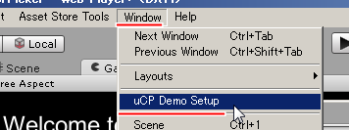

It will show you a confirm dialog.
Please be careful, if you are still editting a scene.
That won't be saved.

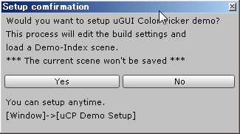
If [Yes], uCP register demo scenes on build settings and load Demo-Index scene.
Then you can play Demos.

When the dialog was shown, uCP creates "Assets/uCUIColorPicker/Demo/Resources/setupfile”.
This is for automatic setup.
If delete it, automatic setup dialog will popup again.

Demo scene “Demo-Index”
This scene is a hub scene.
You can access all demo scenes from here.

Demo scene “Demo-HowTo”
This scene tell you, how to create a color picker and others.
I recommend you to see it once.

Demo scene “Demo-PresetSample”
This scene introduce prefabs.
How are they working and picking colors.

Demo scene “Demo-Animation”
This scene tell you, how to show a color picker.
And it also tell you how to set a color to the color picker.

Demo scene “Demo-WorldUI”
This scene show you samples on world space.
There are 4 themes.

1.ColorSphere
This is for a normal object.
When touch the object, a color picker appears.

2.LightRoom
This is for light sources.
There are 3 lights and 3 controls.

3.SkyBoard
This is for a camera.
It's a Red and Green type color picker with Blue slider.

4.Ground canvas
It's a bigger color picker.
Hue and Value with Saturation vertical slider + Alpha horizontal slider.
It paint both a character and itself.
But in this demo, the character's material doesn't allow it to be transparent.
If you want your character to be transparent, check your character's material.

Demo scene “Demo-D&M”
This scene show you one preset that is included Dropper and MemoryColor.
These 2 are available on version 1.3.
It's useful for using color, that is you wanted.
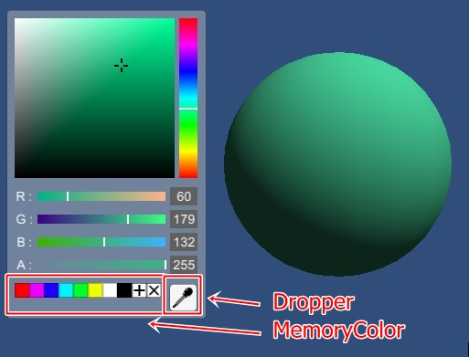
When click a dropper button, the dropper will create another canvas.
This canvas is not visible and has an OnPointerClick event.
When clicked this canvas, the dropper get the color, that is behind the pointer.
Just a bit be careful about a priority of both GraphicRaycaster.cs and DropperGraphicRaycaster.cs.

When add a color to MemoryColor, select a color and click “+”button.
When get a color from MemoryColor, click colors.
And if you want to delete a color, select a color and click “x”button.

MemoriColor.cs has 3 useful functions.
- Public virtual void SetColors (Color[] colors);
- Public virtual Colors[] GetColors ();
- Public virtual void Clear ();
If you want to save color data, use GetColors.
And then you can recover them using Clear and SetColors.

How to use prefabs
There are useful preset prefabs in prefabs folder.
Path : "Assets/uCUIColorPicker/Prefabs/Preset"
When put some of them in a canvas, You just need to set a OnChange event.
Then it will work nicely!
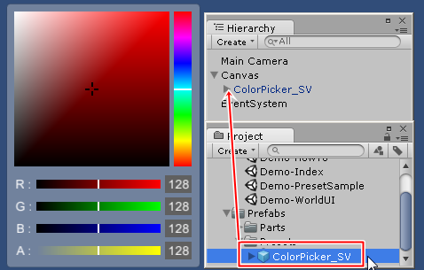
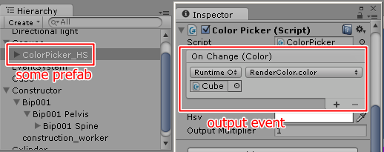
For the output event, you can make a property or a function.
example C# code.
/*-----------------------------------------------*/
// property.
public Color someProperty { get; set; }

// function.
public void someFunction ( Color c )
{
// TODO something.
}
/*-----------------------------------------------*/

If objects have this code, the event can setect it as a dynamic parameter.

How to create a color picker without prefab
uCP is fully customizable.
So you can create a color picker as you like.

Step 1. Create a Base
Create a canvas and a panel.
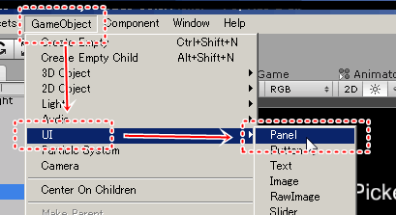
Put a ColorPicker.cs to the panel.
This is base of a color picker.

Step 2. Create controls
Create images and inputs.
These have to be a child of the panel.
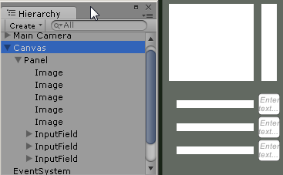

Step 3. Put Components
Put GetColorInRect.cs to images.
Put GradationRect.cs to images except they are for Hue.
Then set X_Axis and Y_Axis properties in inspector window, like the screenshot below.
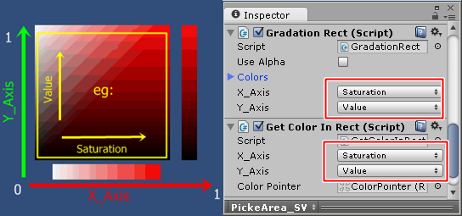
Also put ColotInputField.cs to inputs.
Then set a Property in inspector.

Step 4. Create a Hue control
When you use Hue control, I recommend to use a prefab.
However, you can create specific object like below.
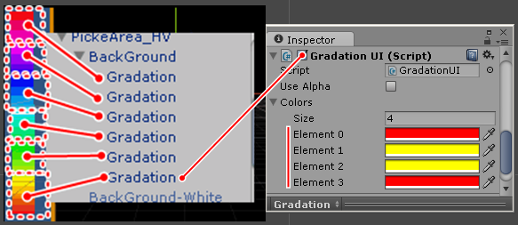
These “Gradation” objects have GradationUI.cs.
This script paints a gradation on a image.
6 images have different Colors and they are placed side by side.
( recommend to use layout components )
These Colors are set with constant corners.
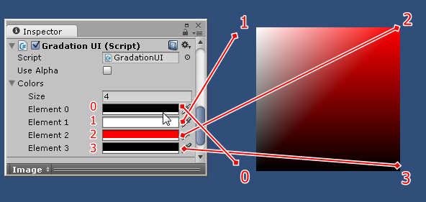
If you want to make a “Hue and Saturation” rect control, that is made of 3 layers. (behind, middle and top)
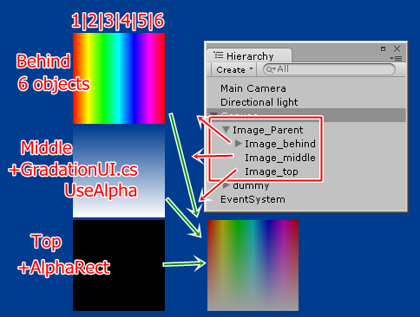
A behind layer is a Hue image object.
If you want to know how to create, see the previous paragraph.

A middle layer contains a GradationUI.cs.
You need to set UseAlpha is true and Colors are white.
Then set Alpha of both Color 1 and Color 2 are 0.
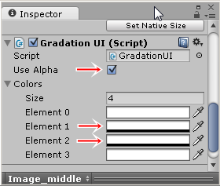
A top layer contains AlphaRect.cs.
It makes a transparent gradation image that related with Property.
You need to set UseAlpha is true and Colors are black.
Also set InverseValue, this works as Alpha = 1 – Property.
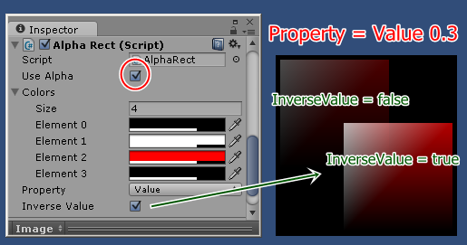
These are “Hue and Saturation” case.
If you need to create “Hue and Value” type, change a middle layer and a top layer.
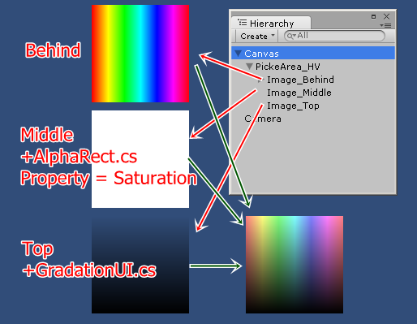
A middle layer has AlphaRect.cs and its properties are
UseAlpha is true, Colors are white, Property is Saturation and InverseValue is true.

A top layer has GradationUI.cs and its properties are
UseAlpha is true, Colors are black and only Alpha of both Color 1 and Color 2 are 0.
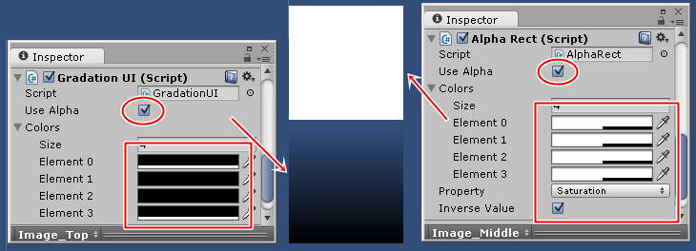

Step 5. Color Pointer
When controls are created, you can put a pointer in each control.
Create an image and Set it to a child of a control.
Choose GetColorInRect.cs and set a ColorPointer property.
You can add a mask component, it works nice.
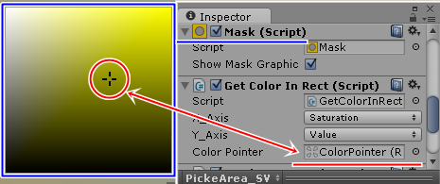

Smaller structure
uCP is able to work with just 1 object.
This's useful for specific situations.
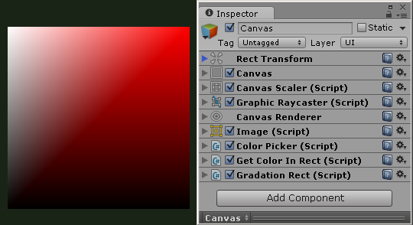
If you don't need a dynamic color control, you can remove the GradationRect.cs.
If you don't control, you can remove the GetColorInRect.cs.

Useful scripts.
There are a few useful scripts, not only for uCP.

- GradationUI.cs
This makes a gradation on Image.
Your UI will be more rich!

- HSV.cs
This allow to use HSV type color.
It can be convert with Color implicitly.
Example C# code.
/*------------------------------------*/
Color c = new HSV ( 1,1,1,1 );
/*------------------------------------*/
And it has constant Colors.
HSV.red, HSV.green, HSV.blue,
HSV.cyan, HSV.magenta, HSV.yellow,
HSV.white, HSV.gray, HSV.grey, HSV.black,
HSV.clear

- RenderColor.cs
This is for all scene objects, they have a Renderer.
This has a function, it can receive a ColorPicker's output event.
And then this sets the renderer's color property.

When you use uCP scripts in your script, you need to write a line, “using uCP;”.
This is the uCP core scropt's namespace.

About ColorPicker.cs.
ColorPicker.cs is a base of uCP controls.
This manage a color and events.
When uCP controls have run Awake(), they find a ColorPicker.cs in their parents and set events.
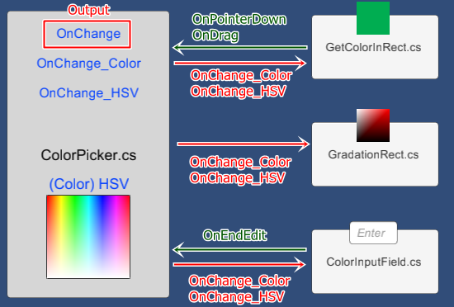
ColorPicker.cs has a OutputMultiplier propety,
It works as OutputMultiplier * Color.
If you felt the color is not enough, try it please.
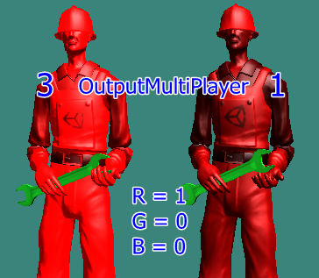

World UI
uCP works even a canvas is world space mode.
Just a bit careful about size.
When you convert Rendermode, overray to world space, the canvas is too big.
Also uCP controls and prefabs are too big.
I recommend to use a CanvasScaler.
This component converts the size very well.
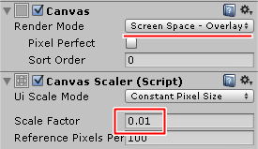
After conversion, change the Render Mode property to world space.
The size good for the world.

About Filled Type Image
When you use Filled type.
GradationUI.cs can not show a gradation correctly.
Please use another image with a Mask.
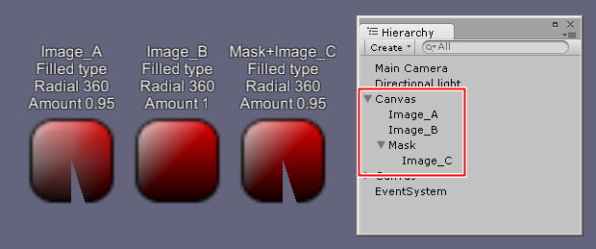

Contact
If something happened, please contact me.

E-Mail : syu-ya_ST@hotmail.co.jp

